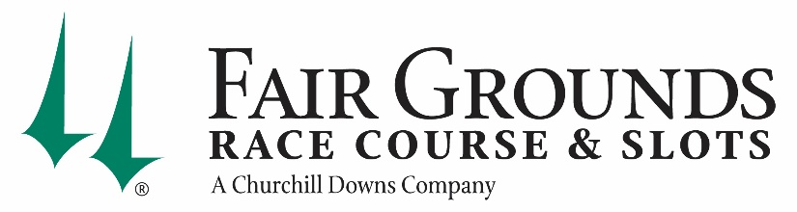

VERY IMPORTANT COVID-19 UPDATE

TO: All Fair Grounds Owners, Trainers & Barn Personnel
FROM: Doug Shipley, President Louisiana Operations
DATE: October 4, 2021
RE: City of New Orleans COVID-19 Mandate

Horsemen, welcome to Season 150! Effective Monday, August 23rd, Fair Grounds had to mandate that all team members and anyone on Fair Grounds property follow The City of New Orleans COVID-19 Vaccine Mandate. This mandate states that anyone entering a business in Orleans Parish, including employees must show proof of being fully vaccinated, or has had at least 1 injection of the vaccine, or show proof of negative COVID -19 test results every 72 hours. Please see specifics below in order to gain entrance into property:
- FULLY VACCINATED Can get LSRC license stamped by Racing Department. ID Badge must be worn in clear view at all times.
- PARTIALLY VACCINATED (received 1 shot only). Must present vaccination card daily until fully vaccinated. Once fully vaccinated, can get LSRC license stamped by Racing Department.
- PROVIDING NEGATIVE COVID TEST Must present negative test results that is not older than 72 hours each day. PCR test is required.
We continue to encourage all employees and barn area personnel to get the vaccine to help stop the unprecedented level of hospitalizations statewide and the growing number of deaths due to the more contagious and more deadly Delta variant.

